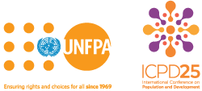

**UNFPA**

**Djibouti Country Office**

**Youth and Adolescents comprehensive package on Sexual Reproductive Health and Rights**

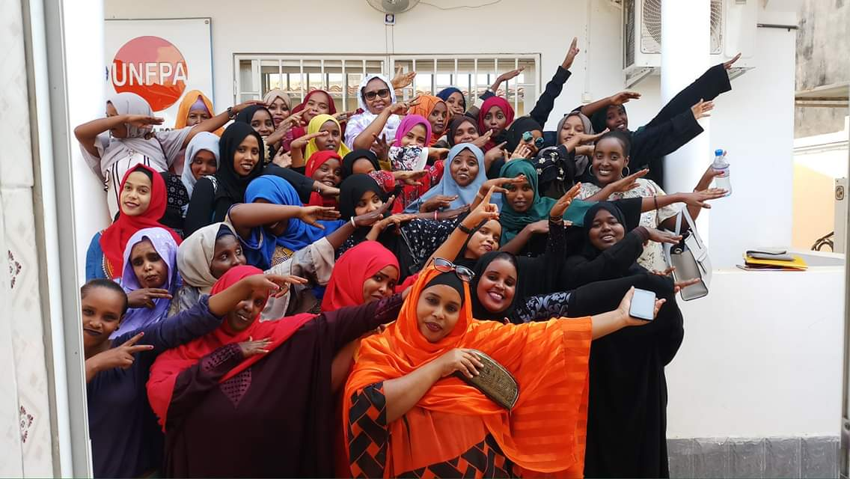

**Campaign against medicalization of FGM and more**

The Y-PEER network launched a social media campaign against FGM engaging 6,333 young people in discussions on the harmful effects of FGM, the need to adopt a law criminalizing the practice, and the emergence of FGM medicalization. *Photo © UNFPA Djibouti*

**Using social networks to combat FGM**

UNFPA and the Djibouti Association for balance and family wellbeing organized a training in the national institute of public administration for young peer educators on the use of FGM –related networks.

A total of 36 young men and women from groups and association received a training on the use of social networks to share information on FGM and sexual health of adolescents and young people from a human rights perspective.

The training focused on selecting the most adequate social networks (Facebook, Instagram, YouTube, Linked….) for different target audiences.

It also looked at ways to plan, execute and measure the impact of a communication strategy. The training also revived the role of UNFPA supported youth- friendly center, where young people are able to meet express themselves and exchange knowledge. *Photo © UNFPA Djibouti*

.

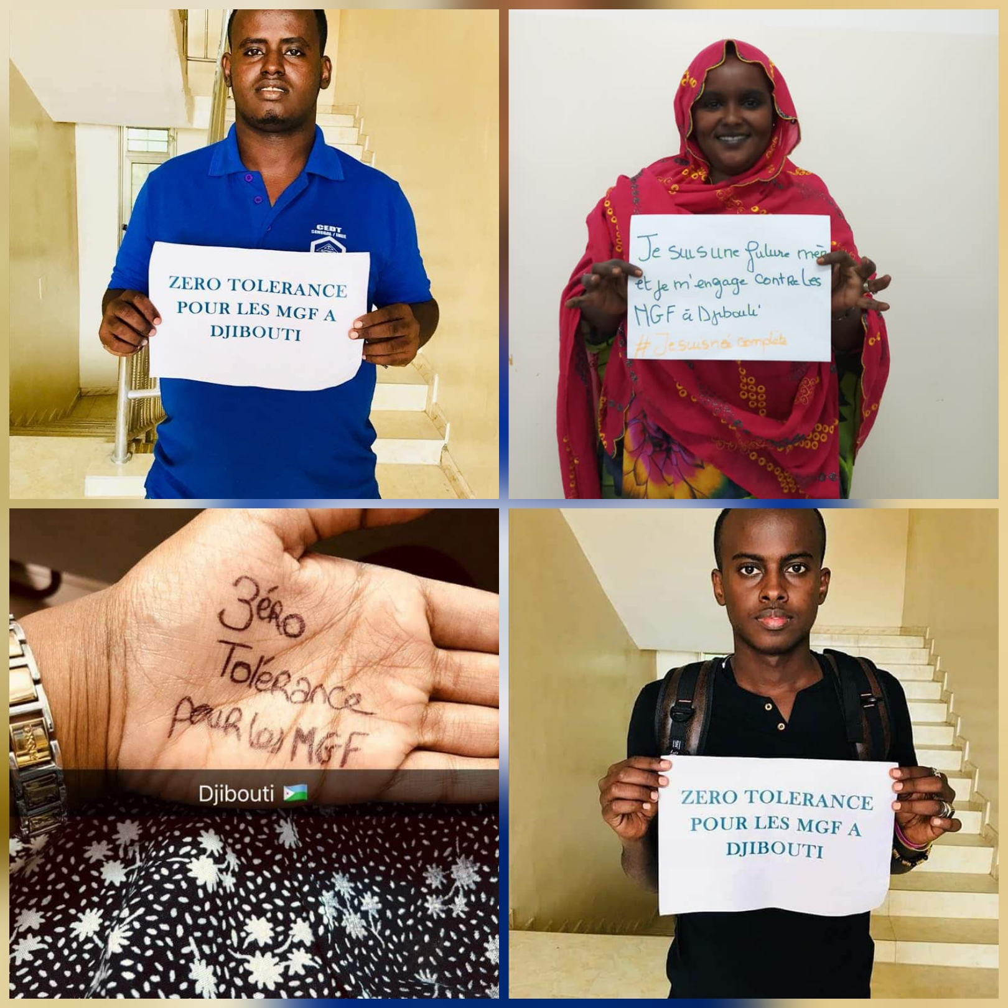

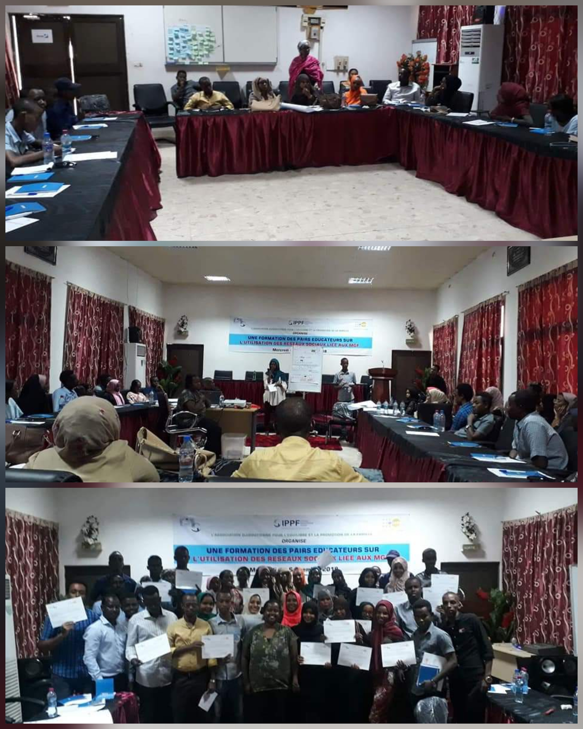

**New adolescent-friendly centre to empower girls**

UNFPA in collaboration with the National Union of Djiboutian Women, inaugurated an adolescent-friendly centre to provide girls with safe spaces where they can receive information on sexual and reproductive health services.

The Centre includes a computer room and a library and will provide: reproductive health information and services including HIV/AIDS, gender-bases violence response services including FGM, soft skills training sessions on self-esteem and personal growth. On the long term, the centre should accommodate 400 marginalized girls. . *Photo © UNFPA Djibouti*

**Training Vulnerable Adolescents on Sexual Health and Reproductive Rights**

UNFPA, in collaboration with the National Union of Djiboutian Women, launch a 5-day training course for 28 young peer educators on the sexual and reproductive health of young women and girls for the establishment of the adolescent-friendly space within the UNFD. *Photo © UNFPA Djibouti*

**Allowing adolescents and young people to reach their full potential**

UNFPA offers opportunities for adolescents and young people to take part in national, regional and international trainings, as well as international events such as the regional forum of the Arab region. *Photo © UNFPA Djibouti*

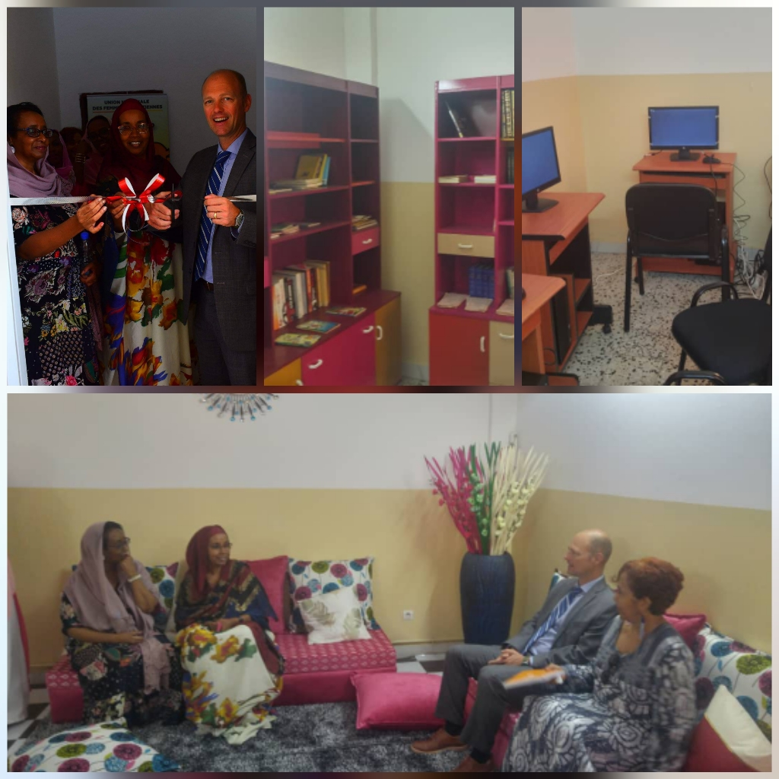

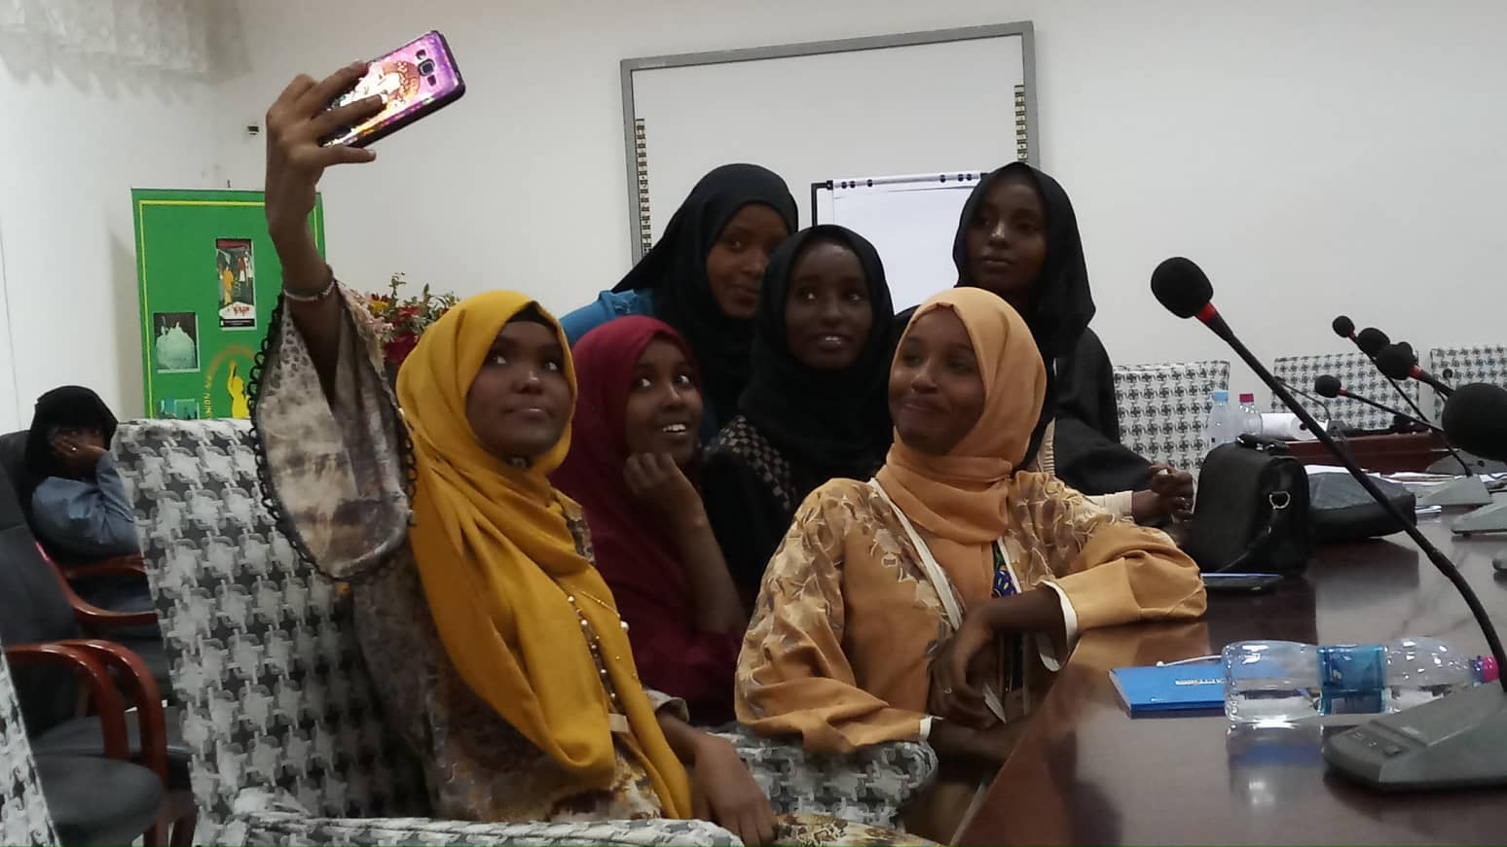

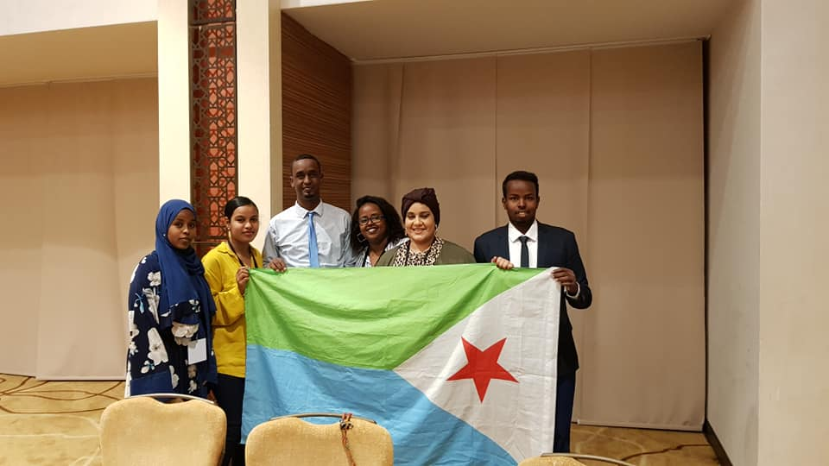

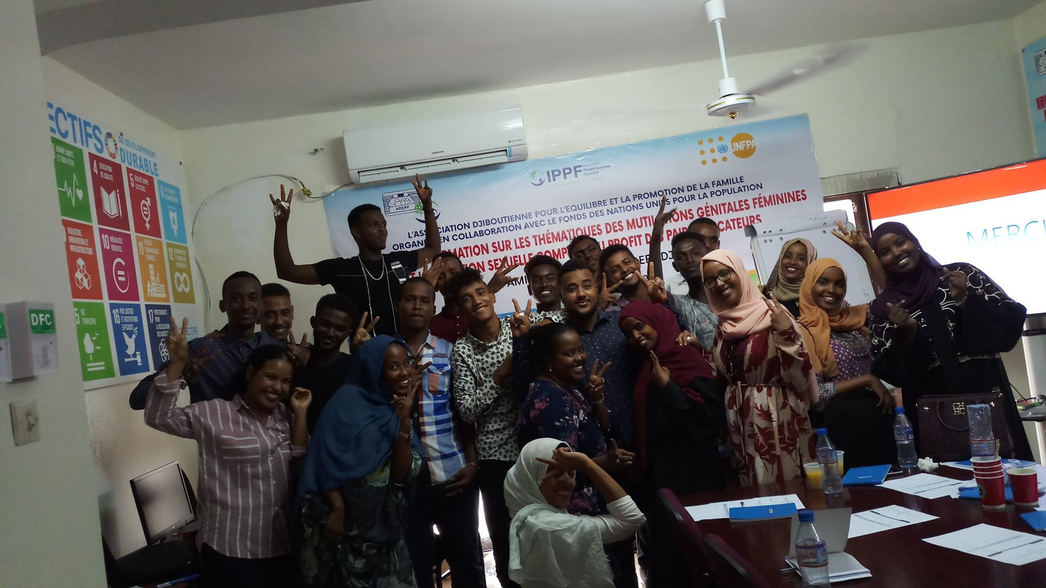

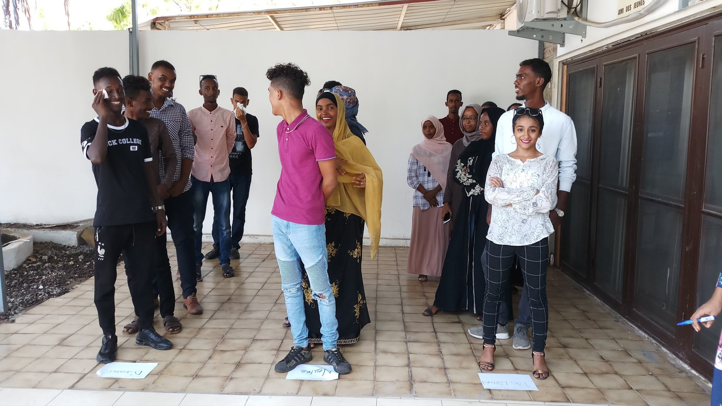

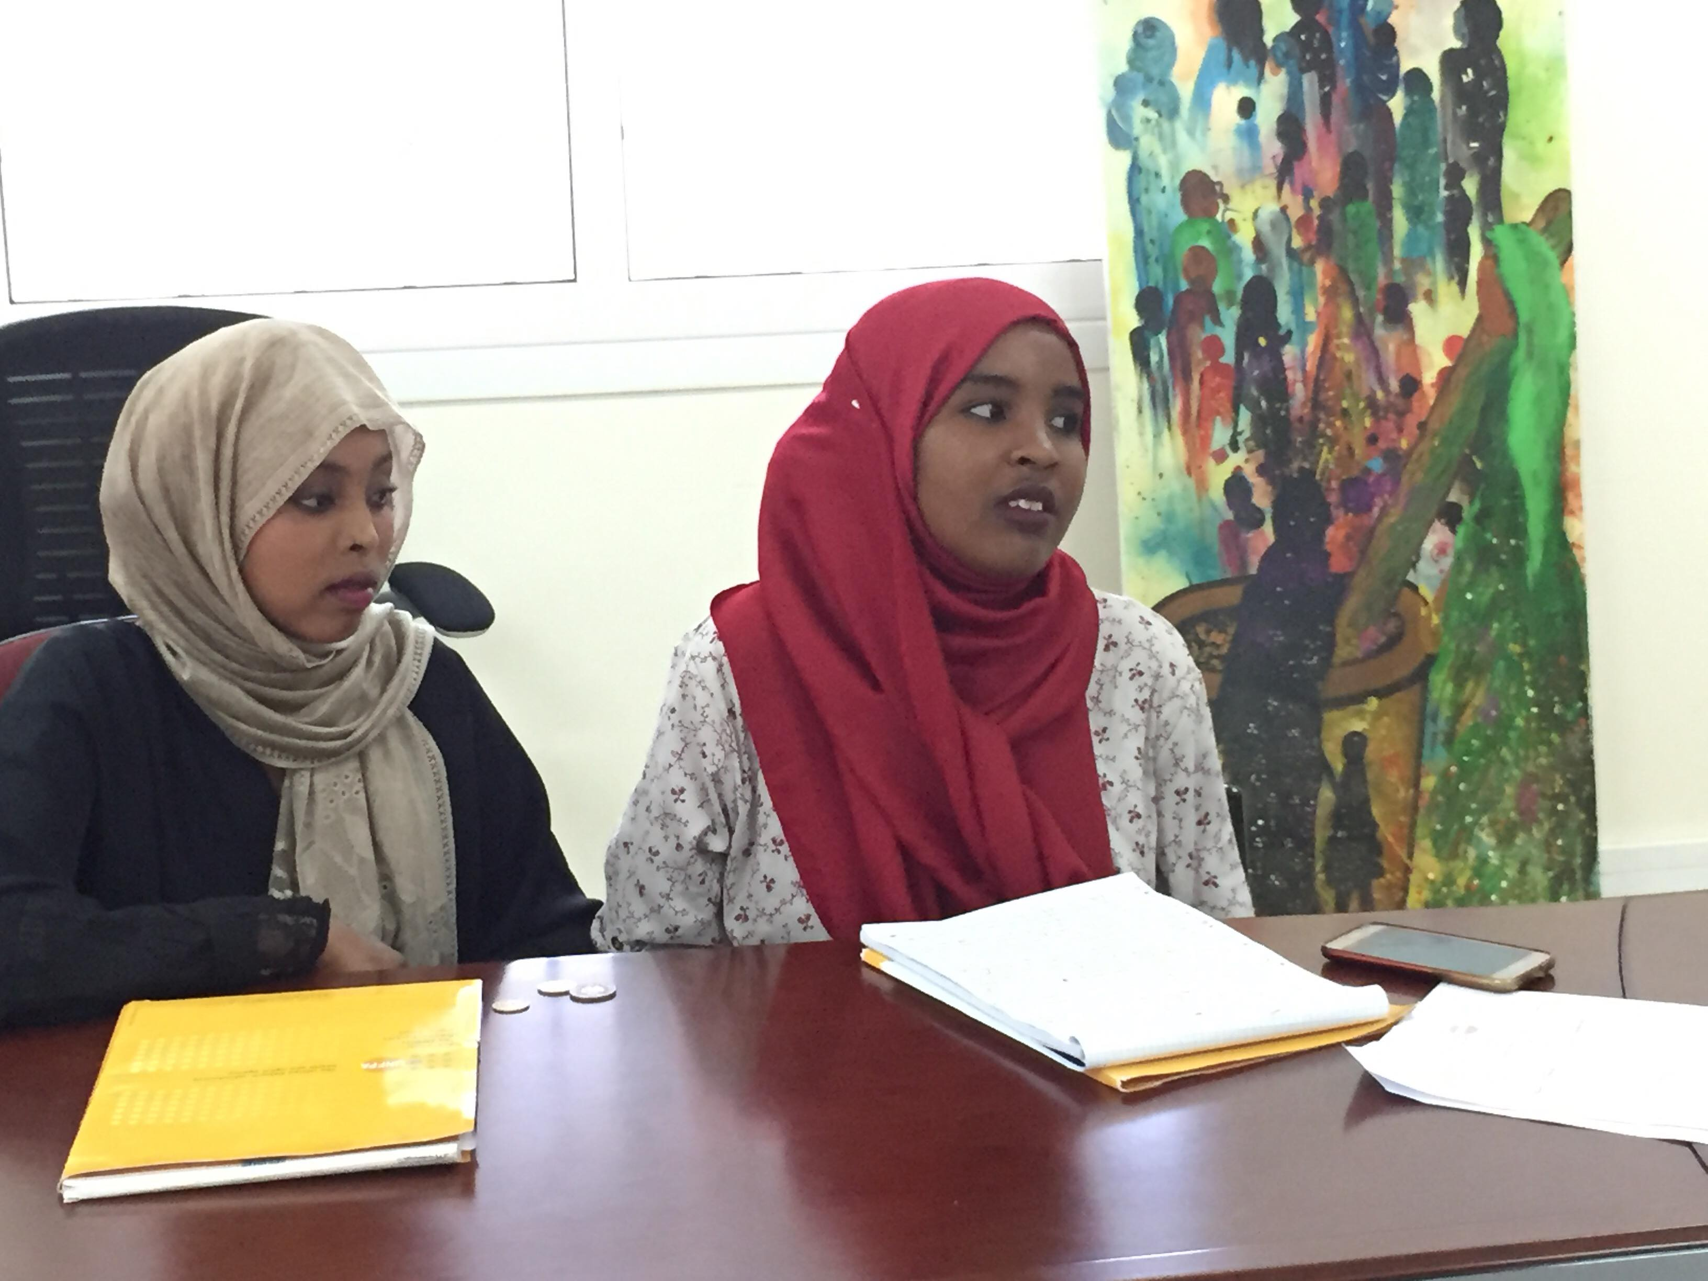

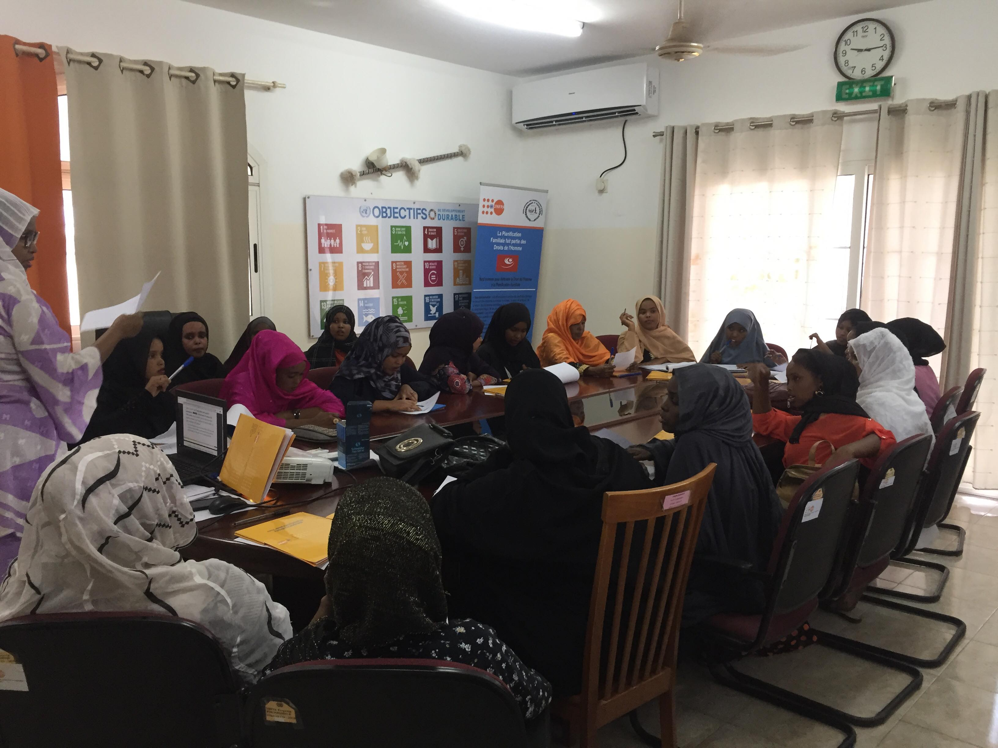

**Engaging youth for their future**

UNFPA in partnership with l’Association Djiboutienne pour le Bien Eater et l’Equilibre Familial(ADEPF) organized a training on sexual and reproductive health and rights for young people and adolescent to support the youth friendly center.

The training aimed at raising the awareness of 25 young peer educators from civil society, schools and university about risky behavior related to their sexuality and harmful practices, including FGM.

At the end of the training, the young trainers signed a commitment charter to end gender-based violence and harmful practices and to cascade their knowledge to the peers. *Photo © UNFPA Djibouti*

**Empowering community young leaders**

UNFPA organized a training on reproductive health and rights for 35 young girls from seven community-based organizations.

The purpose of the training was to raise the awareness of the young participants about reproductive health, family planning and gender-based violence from a human rights perspective.

The trainees developed community-based projects to end early pregnancy, occasional prostitution, and risky behaviors.

UNFPA will support the proposed projects. *Photo © UNFPA Djibouti*